Replication rule for replicate data from one ac to anotther ac

Prefer replication of data from one bucket to another only changes with browsing in that case we select replicate data in another ac

1. In that case we select another ac id which we want to replicate data.
2. And bucket name of that ac
3. Procedure
4. First select bucket.
5. Go to management of that bucket.
6. Go to create replication rule.
7. Follow same procedure as like replication rule for replicate data from bucket o bucket.
8. Only difference is that in case we want to add another ac id and bucket name of that ac in that bucket we want to ad data.

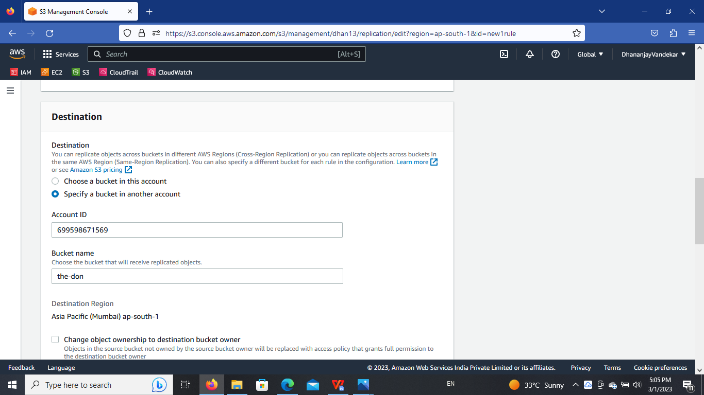

Then upload data in the choosen bucket same data replicate in another bucket which we mention.

This is our bucket.

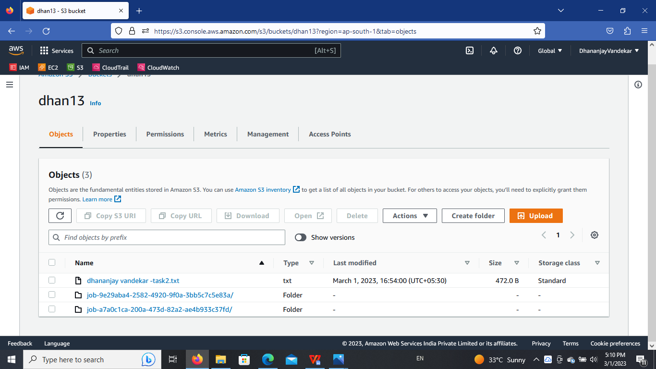

Below is another ac bucket.



This is the replication rule for replicate data from one ac to another ac.